**DAILY ONLINE ACTIVITIES SUMMARY**

|  |  |  |  |  |  |  |  |  |
| --- | --- | --- | --- | --- | --- | --- | --- | --- |
| **Date:** | **20/05/2020** | | | | | **Name:** | **AKASH S** | |
| **Sem & Sec** | **4TH&A** | | | | | **USN:** | **4AL18CS004** | |
| **Online Test Summary** | | | | | | | | |
| **Subject** | | **OBLECT ORIENTED CONCEPT** | | | | | | |
| **Max. Marks** | | **30** | | **Score** | | | **17** | |
| **Certification Course Summary** | | | | | | | | |
| **Course** | **PYTHON FOR MACHINE LEARNING** | | | | | | | |
| **Certificate Provider** | | | **GREATLEARNING** | | **Duration** | | | **5 HOURS** |
| **Coding Challenges** | | | | | | | | |
| **Problem Statement:1:Write a c program to Reverse a Linked List(SLL) in groups of given size.**  **Program Statement 2: Given an array a[] of size n which contains elements from 0 to n-1, write a program print Duplicates which prints the duplicate elements of the given array. If no duplicate element is found print -1.** | | | | | | | | |
| **Status: executed** | | | | | | | | |
| **Uploaded the report in Github** | | | | | **YES** | | | |
| **If yes Repository name** | | | | | **https://github.com/akashacharya786/lockdown-coding** | | | |
| **Uploaded the report in slack** | | | | | **YES** | | | |

Online Test Summary:

18CS43 the test was from 1st module which was about Introduction TO C++. There are 30 questions and the duration 40minutes.The score that I received was 17/30.



Online Certification course:

Name of the course: Python for machine learning.

In the Third day I learnt how the conditional, looping statements works in python and also I learnt about Numpy

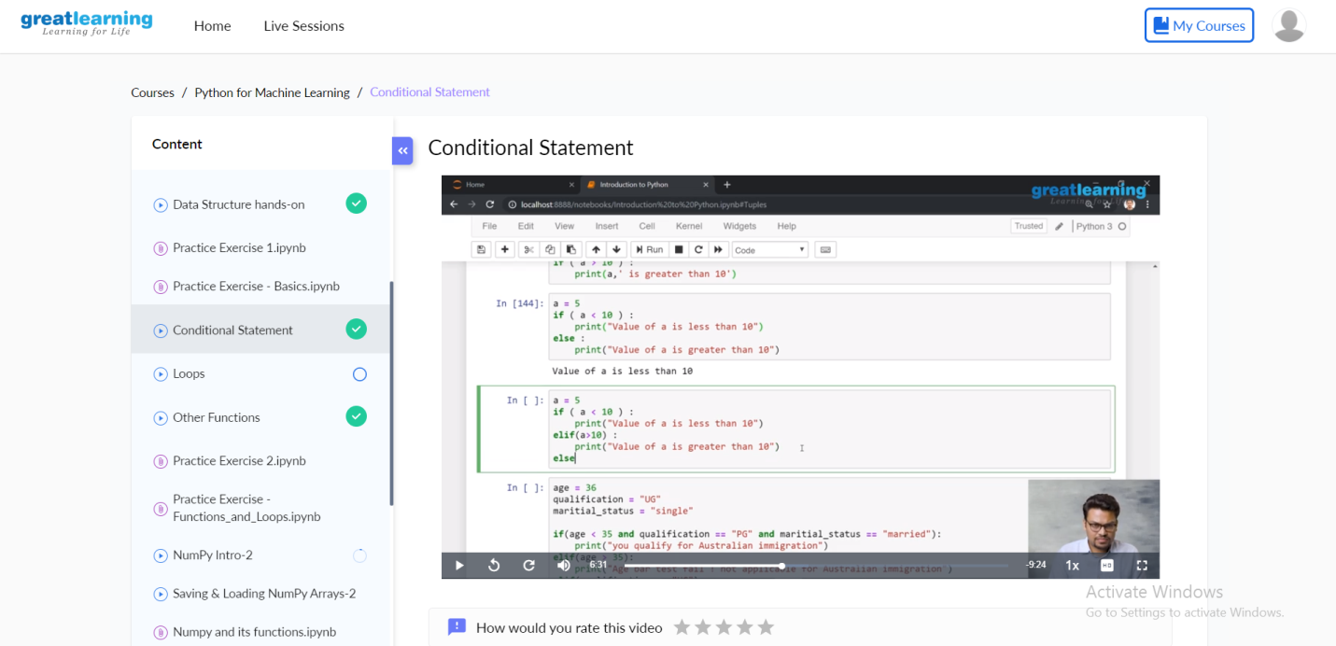

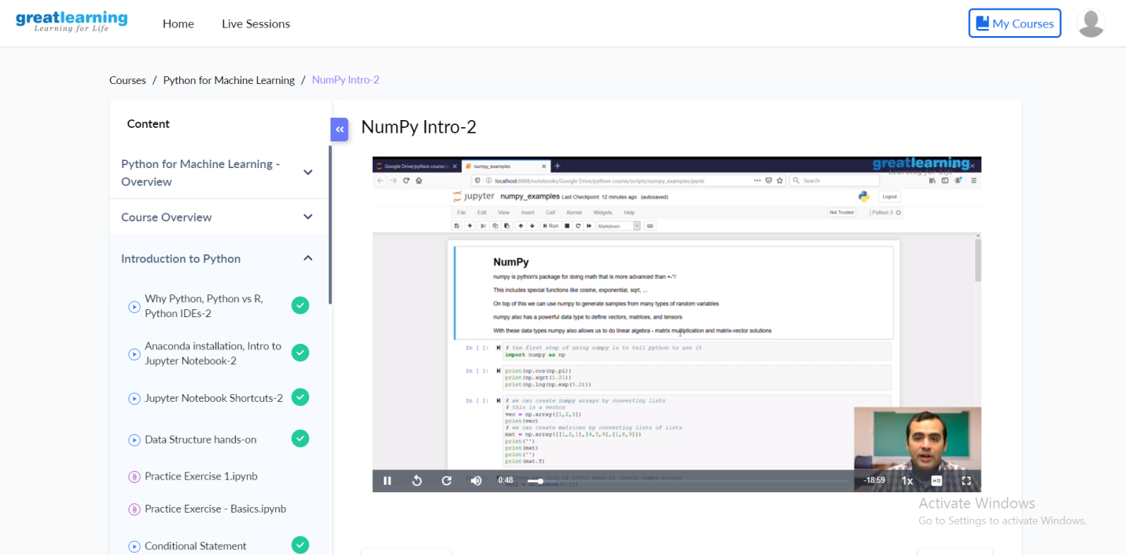

Online Coding summary:

1.Write C Program to Reverse a Linked List(SLL) in groups of given size.

Test Case 1:  
If a linked list is: 1 → 2 → 3 → 4 → 5 → 6 → 7 → 8  
The value of size k is 2  
Then the linked list looks like: 2 → 1 → 4 → 3 → 6 → 5 → 8 → 7

Test Case 2:  
If a linked list is: 1 → 2 → 3 → 4 → 5 → 6 → 7 → 8  
The value of size k is 3  
Then the linked list looks like: 3 → 2 → 1 → 6 → 5 → 4 → 8 → 7

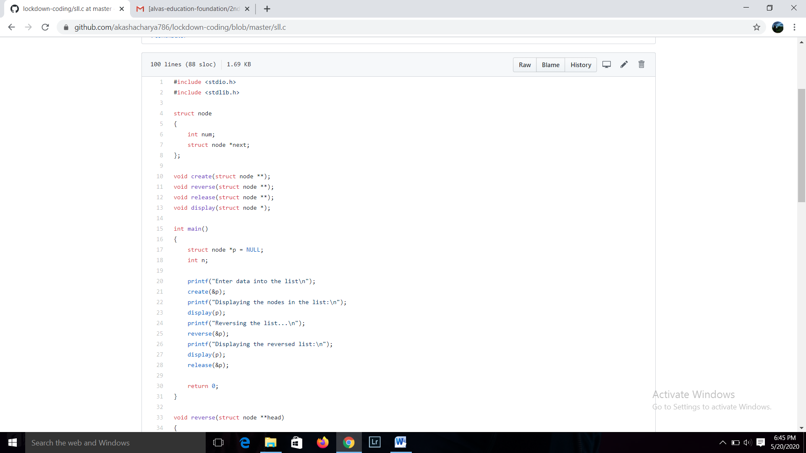

2.Given an array a[] of size n which contains elements from 0 to n-1, write a program print Duplicates which prints the duplicate elements of the given array. If no duplicate element is found print -1.  
Input:  
The first line of input must contains an integer n which denotes number of elements of Array. Second line contains n space separated integers denoting elements of array a[].

Output:  
Print the duplicate elements from the given array.

